Paper 1 MCQ Answers:
1 | 2 | 3 | 4 | 5 | 6 | 7 | 8 | 9 | 10 | 11 | 12 | 13 | 14 | 15 | 16 | 17 | 18 | 19 | 20
C | B | C | D | A | C | A | C | A | D | C | C | A | C | A | D | A | B | D | B
21 | 22 | 23 | 24 | 25 | 26 | 27 | 28 | 29 | 30 | 31 | 32 | 33 | 34 | 35 | 36 | 37 | 38 | 39 | 40
C | B | C | D | C | C | B | A | B | A | D | B | B | C | B | A | B | A | A | C

Paper 2
1(a)
(i) Mg⁺(g) → Mg²⁺(g) + e⁻

(ii) The second ionisation involves removal of an electron from the 3p subshell from Si⁺, and the 3s subshell from Al⁺. Since the 3p subshell is on average further from the nucleus / at a higher energy level / experiences more shielding than the 3s subshell, the electron removed from Si⁺ is less tightly held and requires less energy to remove.

(b) Neon, being already in the gaseous state, is ionised first and emits light,
whereas sodium is in the solid state and takes time to vaporise before it can be ionised.
OR
Neon has a higher first ionisation energy than sodium. The initial power surge when the light is turned on is able to ionize neon, giving rise to the red light,
after which the power drops and is only enough to ionise sodium, giving rise to the orange light.

(c)
(i) Al₂O₃ has a giant ionic lattice structure with strong ionic bonds / high lattice energy / partial covalent character, hence it is insoluble.
SiO₂ has a giant molecular structure with strong covalent bonds requiring large amounts of energy to break, hence it is insoluble.

(ii) AlCl₃ dissolves to give [Al(H₂O)₆]³⁺(aq) which undergoes hydrolysis due to the high charge density on Al³⁺:
[Al(H₂O)₆]³⁺ → [Al(H₂O)₅(OH)]²⁺ + H⁺
OR 2AlCl₃ + 6H₂O ⇌ Al₂O₃ + 6HCl
OR AlCl₃ + 3H₂O ⇌ Al(OH)₃ + 3HCl
SiCl₄ hydrolyses in water to give HCl, a strong acid / H⁺ is produced:
SiCl₄ + 2H₂O → SiO₂ + 4HCl
OR SiCl₄ + 4H₂O → Si(OH)₄ + 4HCl

(d)
(i) Solubility of Li₂O is lower than that of BaO. Therefore, the basicity of Li₂O is also lower than that of BaO.

(ii) Percentage change in mass
= 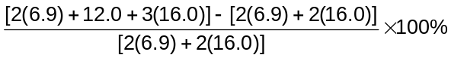
= 61.1%
[Total: 12]
2(a)
x NH₄NO₃(l) + aq → NH₄NO₃(aq)

71 -50

NH₃(g)+ HNO₃(g)
-31 + 37
NH₃(aq) + HNO₃(aq)

From energy cycle, show
x = 71 -31 + 37 -50
= +27 kJ mol⁻¹

(b) The reaction is endothermic as the temperature of the reaction mixture drops. ΔS is positive as the number of gaseous molecules increase from 0 to 1.
Since reaction is spontaneous, ΔG <0.
ΔG = ΔH - TΔS, -TΔS must be more negative than ΔH.

(c)
(i) Undergoes substitution

(ii)

Br₂,
Fe or FeBr₃
Conc. HNO₃ + conc. H₂SO₄
50 – 60 ºC

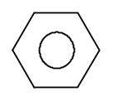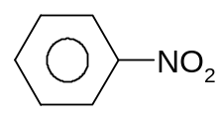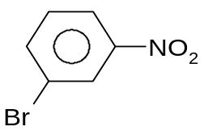
(i) Sn, conc. HCl, reflux
(ii) NaOH(aq)

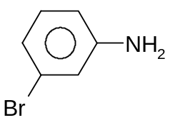
[Total: 10]

3(a) Cr: 1s² 2s² 2p⁶ 3s² 3p⁶ 3d⁵ 4s¹ or [Ar] 3d⁵ 4s¹
Cr³⁺: 1s² 2s² 2p⁶ 3s² 3p⁶ 3d³ or [Ar] 3d³

(b)
(i) Cr S N
Mols 0.298 1.19 2.09
Ratio 1 4 7
x + y + 1 = 7
x: 4 y: 2

- +3

(iii)
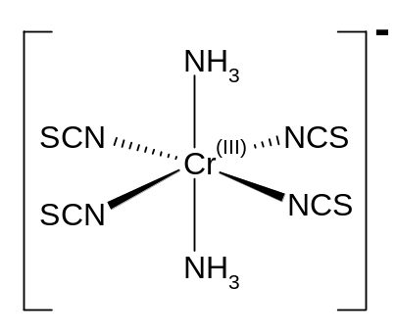
:
:
:
:
..
..

(c)
(i) K₂Cr₂O₇ + 2 HBr → 2 KCrO₃Br + H₂O

(ii) No, oxidation no. of Cr doesn’t change, remains at +6

(iii) Eº_{cell} = +1.33 – (+1.07) = +0.26 V >0
Products should be Cr³⁺(aq) and Br₂(l)

(iv) Reaction didn’t take place at standard condition.
OR The reaction in step I took place under cooled conditions.

(v) AgBr

(vi) Cr is reduced from +6 (orange solution of Cr₂O₇²⁻) to +3 Cr³⁺ (deep green solution)
[Total: 16]

4 (a)
3 Fe(s) + 4 H₂O(g) Fe₃O₄(s) + 4 H₂(g)
Initial mol: - 0.1 - 0
Equilibrium mol: - 0.045 - 0.055
Total mol = 0.045 + 0.055 = 0.1

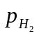 = (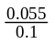) 1.5 atm = 0.825 atm
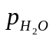 = (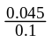) 1.5 atm = 0.675 atm

K_{p} = 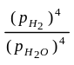 = 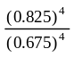
= 2.23

(b) Formation of ammonia is exothermic.
Low temperature is used to obtain higher yield of ammonia.
Since, low temperature is used, the rate of formation of ammonia is slow.
Hence, catalyst is used to increase rate.

Formation of nitrogen dioxide is endothermic.
High temperature is used to obtain higher yield of nitrogen dioxide.
Since, high temperature is used, the rate of formation of nitrogen dioxide is fast.
Hence, catalyst is not required.

(c)
(i) Step I: conc HNO₃ and conc H₂SO₄, 30 ºC
Step II: excess Cl₂, uv light

(ii) Step IV: Elimination (of water) / Dehydration
Step VII: Electrophilic substitution
NO₂

O─H
│
H─O─C─O─H
(iii) P: Q:
CH₃
N

H H

R: S:
O
║
N─C
│
H
CH₃
NO₂

NO₂
Cl
│
C=O

[Total: 12]

5 (a)
(i)
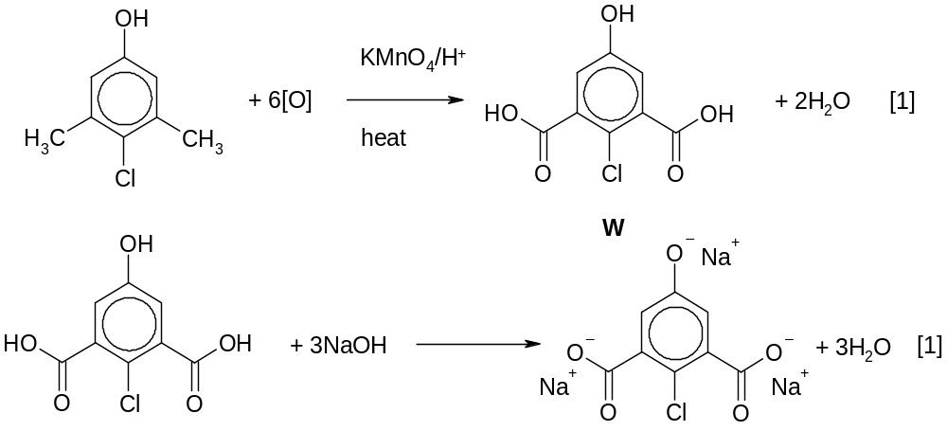

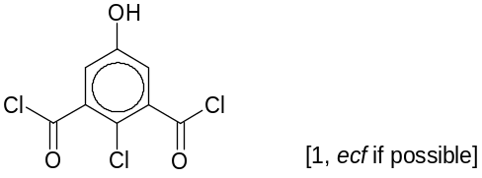
(ii) X :

(iii) Add KMnO₄/H⁺ (aq) and heat to both samples.
For chloroxylenol, purple KMnO₄ is decolourised, but not for 4-chlorophenol.

(b)
(i)
reagents & conditions | type of reaction | organic products
concentrated D₂SO₄, heat | Dehydration / elimination (of water) | 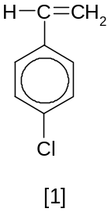
I₂, NaOD, D₂O |  | 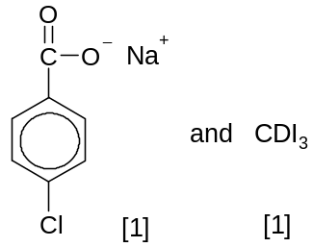

(ii) No (orange) ppt is observed.
Z is not a carbonyl compound (is not an aldehyde or ketone)
[Total: 10]

Paper 3

1(a)
(i) KNO₃ → KNO₂ + ½O₂

(ii) Mg(NO₃)₂ → MgO + 2NO₂ + ½O₂
NO₂, which is produced from decomposition of magnesium nitrate, is toxic/a pollutant.
OR
Decomposition of magnesium nitrate occurs more readily than potassium nitrate, resulting in a loss in control of burning rate at the high temperatures reached in fireworks.
OR
Potassium nitrate releases more mols of O₂ per mass than magnesium nitrate because of its lower M_{r}.

(b) Let the unknown Group II metal be M.
2 Al + O₂ → Al₂O₃
No. of mols of O₂ = 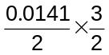= 0.01058
Mass of KNO₃ = 2 × 0.01058 [39.1 + 14.0 + 3(16.0)] = 2.138 g
Mass of MCO₃ = 2.75 – 2.138 = 0.612 g
MCO₃ → MO + CO₂
No. of mols of CO₂ = 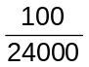= 4.167 × 10⁻³
M_{r}(MCO₃) = 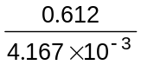= 146.9
A_{r}(M) = 146.9 – 12.0 – 3(16.0) = 86.9 ≈ 87.6
Therefore, M is strontium.

(c)
(i) P^{3–} has a larger radius than S^{2–}.
P^{3–} has a smaller nuclear charge but the same number of electrons as S^{2–}, hence the electrons experience less attraction to the nucleus and spread out over a larger volume.

(ii) State: PCl₅ or phosphorus in oxidation state +5
Phosphorus is able to expand its octet to accommodate 5 electron pairs as it is in Period 3 and thus has empty 3d orbitals of similar energy, whereas nitrogen, being in Period 2, does not have suitable orbitals of similar energy for this purpose.

(d) Test: To each of the compounds, add Br₂(aq).
Observation: Both gallic and shikimic acids will decolorize bromine. However, only gallic acid will give a white precipitate, while shikimic acid will not.
OR
Test: To each of the compounds, add neutral FeCl₃(aq).
Observation: Only gallic acid will give a violet colouration, whereas shikimic acid will give no visible observation.

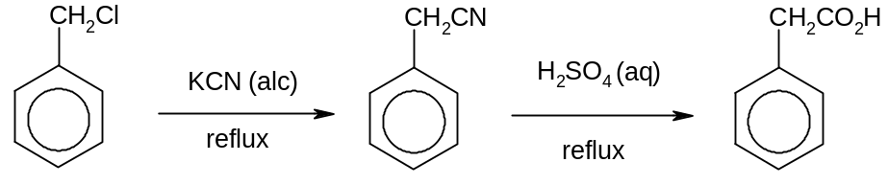 (e)

(i)

(ii) (Chloromethyl)benzene is hydrolysed/undergoes nucleophilic substitution
to give free Cl⁻, which is precipitated as AgCl on addition of aqueous AgNO₃(aq).
OR
balanced equations for nucleophilic substitution and precipitation reactions
2-chloromethylbenzene does not react due to the partial double bond character of the C-Cl bond, which results from the delocalization of the Cl lone pair into the ring.
(Fluoromethyl)benzene does not react due to the strong C-F bond, which is resistant/inert to nucleophilic substitution.
[Total: 20]

2(a)
(i)
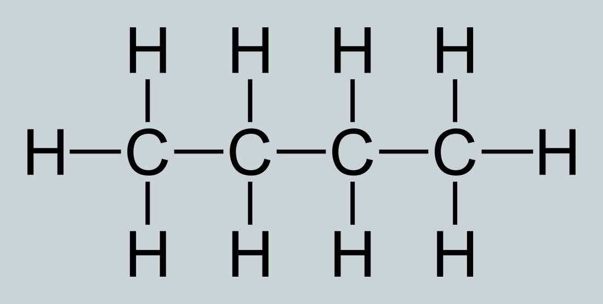 n-butane 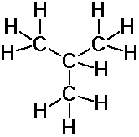i-butane
n-butane has a higher boiling point due to its larger surface area
OR n-butane is a straight chain while i-butane is branched.
Stronger / more extensive intermolecular van der Waals’ forces exist in n-butane.

(ii) methylpropane / 2-methylpropane

(iii) i-butane is inert / unreactive / stable.
OR C-H bonds are strong
OR butane is destroyed before reaching the stratosphere

(iv) Amt of heat absorbed by water = mcΔT
= (1000)(4.2)(75) = 315 kJ
Amt of heat released by burner = 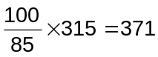 kJ
Amt of butane used = 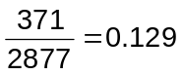 moles
Mass of n-butane used = 0.129 x 58.0 = 7.47 g

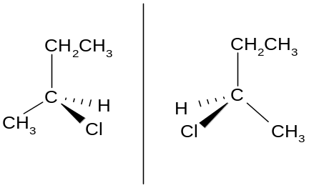 (v)

CH₃CH₂CH₂CH₂Cl

Mechanism: Free radical substitution

(b)
(i) Pass chlorine gas into hot aq. sodium hydroxide
OR Heat NaClO.
3Cl₂ + 6NaOH → 5NaCl + NaClO₃ + 3H₂O
3ClO⁻ → 2Cl⁻ + ClO₃⁻

(ii) ClO₃⁻ + H₂O → ClO₄⁻ + 2H⁺ 2e⁻
Overall: 4ClO₃⁻ → 3ClO₄⁻ + Cl⁻

(iii) pH independent.
H⁺ or OH⁻ is not involved in the overall equation.
[Total: 20]

3(a) S₂O₃² reacts with the I₂ produced and suppresses visible change.
2 S₂O₃²⁻ + I₂ → S₄O₆²⁻ + 2 I⁻
When I₂ produced exceeds amount of S₂O₃²⁻ added, starch turns the solution blue-black due to presence of I₂ formed and the time can be recorded.

(b)
(i) Using Expts 1 and 2,
When the [H₂O₂] is doubled, the initial rates of the expts also doubled, 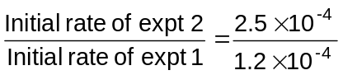= 2.08 ≈ 2.
Thus, the order of reaction wrt [H₂O₂] is 1.

Using Expts 2 and 3,
When the [I⁻] is doubled, the initial rates of the expts also doubled, 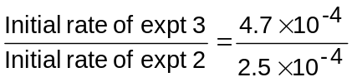= 1.88 ≈ 2.
Thus, the order of reaction wrt [I⁻] is 1.

Using Expts 3 and 4, where [H₂O₂] and [I⁻] are constant at 0.20 mol dm⁻³, with the different pH 5 and 4 respectively, the initial rates of the expts are ≈ 0.47 × 10⁻³ and thus, are more or less constant. Thus, order of reaction wrt [H⁺] is zero at pH 4-5.
Rate = k[H₂O₂][I⁻] at pH 4-5.

(ii) Using Expt 1, k = 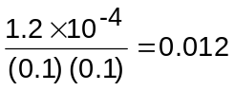
k ≈ 0.012 dm³ mol⁻¹ s⁻¹

(iii) Using Expts 5 and 6,
pH = 0.53 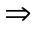 [H⁺]_{expt 5} = 0.295 mol dm⁻³
pH = 0.40 [H⁺]_{expt 6} = 0.398 mol dm⁻³
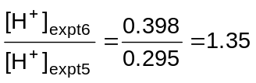
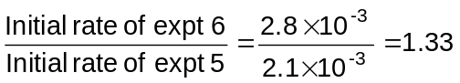

When the [H⁺] increases by 1.35, the initial rates of the expts also increases by 1.33,
Thus, the order of reaction wrt [H⁺] is 1 at low pH.

Rate = k’[H₂O₂][I⁻][H⁺] at low pH.

(iv) The mechanism of the same reaction at different pH conditions are different.
OR
At pH=3-5, rate is independent on the [H⁺] but when pH gets too low, rate becomes dependent on [H⁺].

(v) H₂O₂ + I⁻ → OI⁻ + H₂O (slow)
OI⁻ + H⁺ → HOI (fast)
HOI + I⁻ + H⁺ → I₂ + H₂O (fast)

(c)
(i) Since K_{stab} of [Fe(CN)₆]³⁻ is larger than [Fe(SCN)(H₂O)₅]²⁺, [Fe(CN)₆]³⁻ is the more stable complex. Ligand exchange will occur.
Deep red solution turns orange yellow.

(ii) Fe³⁺ + e → Fe²⁺ +0.77 V
[Fe(CN)₆]³⁻ + e → [Fe(CN)₆]⁴⁻ +0.36 V
From K_{stab}, [Fe(CN)₆]³⁻ is more stable than [Fe(CN)₆]⁴⁻, [Fe(CN)₆]³⁻ is less likely to be reduced than Fe³⁺(aq) or [Fe(H₂O)₆]⁺³.
[Fe(CN)₆]³⁻ is stabilized by CN⁻ ligands, resulting in a lower Eº value.

(d) No. of mols of Ag added = 0.50 / 108 = 4.63 × 10⁻³

Quantity of charge = (4.63 × 10⁻³) × 96500 = 447 C

Time taken = 447 / 0.2 = 2230 s = 37.2 min
[Total: 20]

4(a)
(i) [H⁺] = 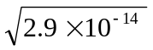 = 1.70 10⁻⁷ mol dm⁻³
pH = - log (1.70 10⁻⁷) = 6.77

(ii) Neutral, as [H⁺] = [OH⁻]
(iii) H₂O(l) H⁺(aq) + OH⁻(aq)

As temperature increases, K_{w} increases; so the equilibrium position shifts to the right. Therefore, the forward reaction (dissociation of water) is endothermic.

(b) CH₃CH₂NH₃⁺ + H₂O CH₃CH₂NH₂ + H₃O⁺

pK_{b} = 3.25
- log K_{b} = 3.25
K_{b} = 5.62 10⁻⁴ mol dm⁻³
K_{a} = 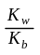= 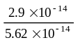 = 5.16 10⁻¹¹ mol dm⁻³

[H⁺] = 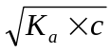 = 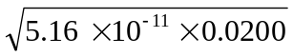
= 1.02 10⁻⁶ mol dm⁻³

pH = - log (1.02 10⁻⁶) = 5.99

(c)
(i) % of N in melamine = (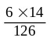) 100 % = 66.7 %

(ii) % of N in urea = (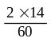) 100 % = 46.7 %
% of N in NH₄NO₃ = (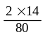) 100 % = 35.0 %
% of N in hydrazine = (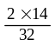) 100 % = 87.5 %

Hydrazine is the best as the % by mass of nitrogen is the highest of all the compounds.
(iii) Melamine is an amine / it can accept a proton due to the lone pair of electrons on the nitrogen atom / RNH₂ + H₂O RNH₃⁺ + OH⁻ (basic due to presence of OH⁻).

(iv) Melamine is less basic than ethylamine.

As the lone pairs of electrons on N atoms are delocalised into the ring, making them less available to accept a proton.
OR
Ethylamine is more basic than melamine as the ethyl group is electron donating, it enhances the electron density on the N atom so that it can accept a proton more readily.
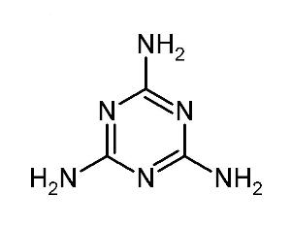
(d)

NH──C──CH₃
║
O
(i)

NH₃⁺CH₃CO₂⁻

(ii)

NHCH₂CH₃

(iii)

(e) The immediate ppt seen suggests that the structure of the compound obtained is ionic in nature, with the precipitation of Ag⁺Br⁻. +

N(CH₂CH₃)₃

. Br⁻ (M_{r} = 291)

(f) Hydrogen bonding
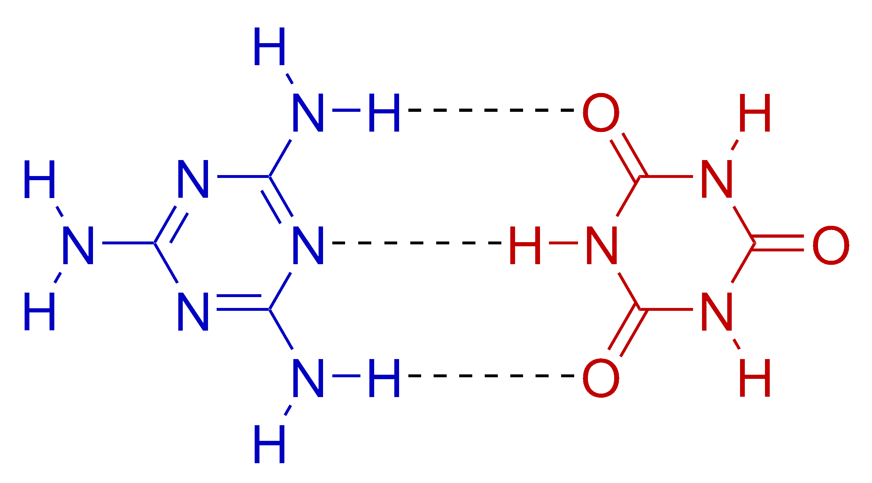

[Total: 20]

5 (a) Nucleophilic addition with :CN⁻ as nucleophile
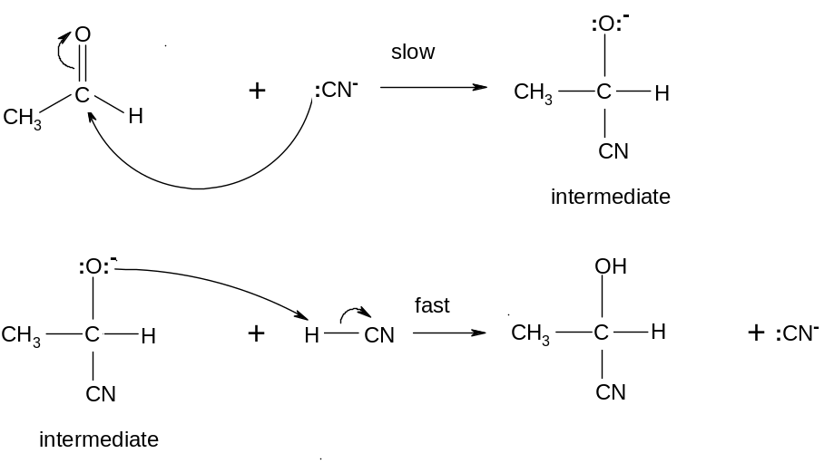
δ-

δ+

δ+
δ-

(b) Oxidation / ester formation / esterification

(c)
(i) CH₃CH₂CH₂OH + HOCH₃
(ii) CH₃CH₂OH

(d)
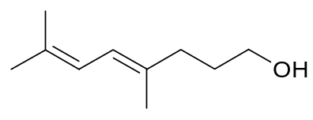
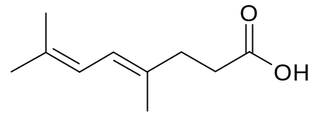
- A: ● B:

- C: CH₃COCH₃
- D: CH₃COCH₂CH₂CO₂H
- E: HO₂C-CO₂H
- A is a (primary) alcohol since it can react with sodium metal and oxidised to a carboxylic acid.
- A undergoes acid-metal / redox reaction with sodium metal or
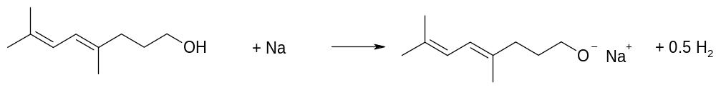

- Effervescence is due to H₂ (g).
- B is a carboxylic acid.
- A has two C=C double bonds / is an alkene.
- A undergoes electrophilic addition with Br₂ / B undergoes electrophilic addition with steam or
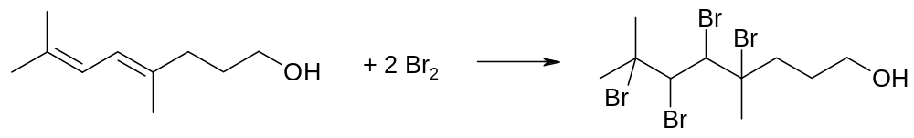

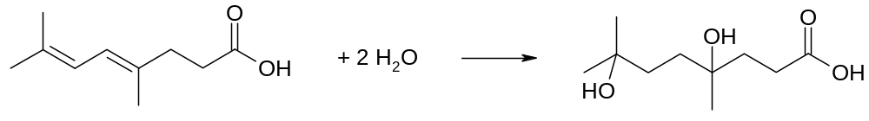

- C and D contain CH₃CO- group / are methyl ketones.
- Yellow precipitate is CHI₃.

- To account for formation of cyclic ester:
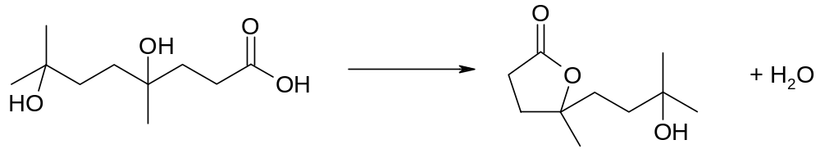

- Product from the esterification undergoes dehydration / elimination (of water) since there is unreacted alcohol to form F or
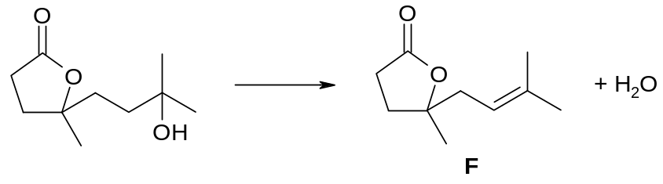

[Total: 20]

